

Service Broker Experiment Storage API

Author: Vijay S. Choudhary
Last Modified: 10/3/05
By: Chris Felknor

Table of Contents

Table of Contents 2
Overview 3
The ExperimentInformation Class 4
public struct ExperimentInformation 4
public struct Experiment 5
Service Broker Data Storage API Architecture 6
Methods 7
Configuration Methods 7
SetResultXMLExtensionSchema 7
SetBlobXMLExtensionSchema 7
Experiment Record Methods 8
CreateExperiment 8
SaveExperimentSpecification 8
RetrieveExperimentSpecification 9
SaveSubmissionReport 9
SaveResultReport 9
RetrieveExperimentResult 10
SaveLabConfiguration 10
RetrieveLabConfiguration 11
SaveExperimentAnnotation 11
RetrieveExperimentAnnotation 11
RemoveExperiments 12
GetExperimentInformation 12
ModifyExperimentOwner 12
ModifyExperimentStatus 13
Search Methods 14
public struct Criterion 14
FindExperimentIDs 14

Overview
The methods in this document define the functionality for storing, deleting, updating and retrieving experiment records. This API, like the Service Broker Administrative API, is intended to specify, at least initially, an internal but self-contained library accessed as part of the Service Broker process. Eventually, it may be useful to expose some or all of the methods described below as web service calls so that the Lab Server or Client may access the Experiment Storage Service directly.
The design recognizes that much of an experiment record is domain-dependent and, therefore, meaningless (opaque) to the Service Broker though intelligible to the Lab Server and the user’s Lab Client. More specifically, the record for a completed experiment consists of three such strings opaque to the Service Broker:
- LabConfiguration,
- ExperimentSpecification, and
- ExperimentResult.

Users will need to be able to search for experiment records and administer them, e.g. delete or archive them, independent of the Lab Server or Client. This implies that the Service Broker must understand certain semantics common to all experiment types. We have segregated the fields that support these semantics in the transparent (to the Service Broker) type, ExperimentInformation (see below). Conversely, we have decided that the Experiment Storage API should have no responsibility for enforcing administrative policy. So, this API treats the fields of the ExperimentInformation object, with the exception of experimentID, as if they were pure data fields. For instance, this API does not check the referential integrity of the userID field in ExperimentInformation. The User class is an administrative concept. When a user is deleted, the decision whether to purge or archive a user’s experiments is an administrative decision. This API will allow the Service Broker or another service to enforce any chosen policy.
The Service Broker architecture needs to be able to store and retrieve three other classes of information:
- convenience or preference items associated with a particular user and software client for accessing a particular lab server;
- unfinished experiment specifications; and
- sets of arbitrary binary data (BLOBs) associated with experiment records, e.g. images and video streams.
The first two classes are not associated with an experimentID or with any interaction with the Lab Server. Because of this, we have chosen to support the first two categories of functionality via the ClientData methods of the Service Broker Administrative API. The third category, however, does describe functionality that extends the basic storage capabilities for experiments and is linked to the concept of experimentID. This functionality was not implemented in the first version of this API. Extensive support for BLOB storage is provided by the second generation general Experiment Storage Service (created to support interactive as well as batched experiments). The developer should consult the Experiment Storage Service Specification (2004-08-18 or later).
As in the Service Broker Administrative API, none of the methods described below will check whether the current user has permission to call the method. We assume that such checks are being performed by the trusted code that invokes these methods using mechanisms detailed in the Service Broker Authorization API.

The ExperimentInformation Class
The transparent ExperimentInformation object associated with each experiment record contains all the information about the experiment that is accessible to the Service Broker. Most of the fields of the ExperimentInformation class are fixed, for example experimentID, effectiveGroupID, userID, etc. They are permanently set by the time the lab server executes the experiment. The Service Broker can, however, change the annotation field for the client after experiment execution. This allows the user to supply a string title or caption to a particular experiment.
Two further fields, xmlResultExtension and xmlBlobExtension, provide an XML-based extension mechanism. These transparent XML strings define sets of attribute-value pairs that are set by the Lab Server and read by the Service Broker. These fields should conform to XML Schemas defined by the lab server for a particular type of experiment. Our intent is to allow searches for experiments and blobs by attribute, but this capability will not be implemented in the first version of the Data Storage API.

public struct ExperimentInformation
{
public readonly int experimentID;
public readonly int labServerID;
public readonly int userID;
public readonly int effectiveGroupID;
public readonly string/DateTime submissionTime;
public readonly string/DateTime completionTime;
public readonly string/DateTime expirationTime;
public readonly double minTimeToLive;
public readonly int priorityHint;
public readonly int statusCode;

public readonly string [] validationWarningMessages;
public readonly string validationErrorMessage;
public readonly string [] executionWarningMessages;
public readonly string executionErrorMessage;

public string annotation;
public readonly string xmlResultExtension;
public readonly string xmlBlobExtension;
}

While the following Experiment class is never formally defined, conceptually it represents the complete record of an experiment.

public struct Experiment
{
ExperimentInformation information;
public readonly string labConfiguration;
public readonly string experimentSpecification;
public readonly string experimentResult;
}

Service Broker Data Storage API Architecture
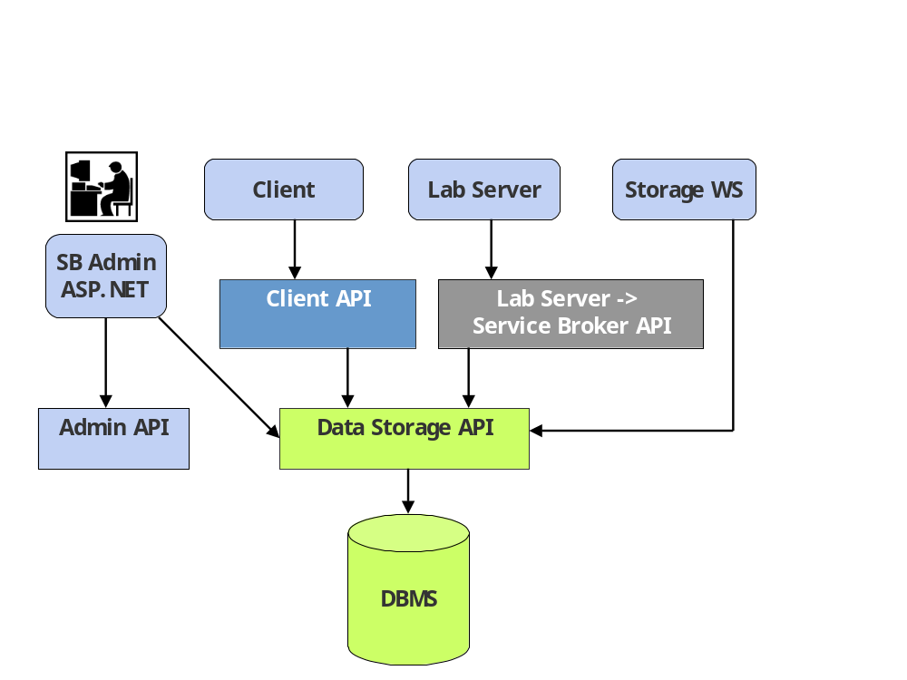

Methods

Configuration Methods

SetResultXMLExtensionSchema
Purpose:
/* Identify the XML schema used to validate the xmlResultExtension data member of the ExperimentInformation class on the Service Broker for experiments executed on the lab server identified by labServerID. Any change to this field should be upwardly compatible. That is, if the xmlResultExtension schema is changed, the new schema should successfully validate all XML documents that were successfully validated by its predecessor. */
Arguments:
int labServerID
/* Identifies the lab server to which the XML result extension applies. */
string URL
/* The URL of the XML schema document defining the new validating schema. */
Returns:
void none

SetBlobXMLExtensionSchema
Purpose:
/* Identify the XML schema used to validate the xmlBlobExtension data member of the ExperimentInformation class on the Service Broker for experiments executed on the lab server identified by labServerID. Any change to this field should be upwardly compatible. That is, if the xmlBlobExtension schema is changed, the new schema should successfully validate all XML documents that were successfully validated by its predecessor. */
Arguments:
int labServerID
/* Identifies the lab server to which the XML BLOB extension applies. */
string URL
/* The URL of the XML schema document defining the new validating schema. */
Returns:
void none

Experiment Record Methods

CreateExperiment
Purpose:
/* Creates an empty experiment record identified by a unique experimentID, which is returned. */
Arguments:
int userID
/* Identifies the user, who becomes the owner of all records pertaining to this experiment. */
int effectiveGroupID
/* Identifies the effective group, which sets the permissions under which the experiment will execute. */
Returns:
int experimentID
/* The unique experimentID. */

SaveExperimentSpecification
Purpose:
/* Records an experiment specification. */
Arguments:
int experimentID
/* Identifies the experiment. */
int labServerID
/* Identifies the lab server on which the experiment will execute. */
int userID
/* Identifies the user. */
int effectiveGroupID
/* Identifies the effective group, which sets the permissions under which the experiment will execute. */
string experimentSpecification
/* An opaque string generated by the Lab Client to specify an experiment. */
string annotation
/* An optional user-defined annotation; null if not used. */
Returns:
void none

RetrieveExperimentSpecification
Purpose:
/* Retrieves a previously saved experiment specification. */
Arguments:
int experimentID
/* Identifies the experiment. */
Returns:
string experimentSpecification
/* The experimentSpecification, a domain-dependent experiment specification originally created by the Lab Client. */

SaveSubmissionReport
Purpose:
/* Saves the portions of the SubmissionReport returned from the Lab Server that belong in the ExperimentInformation object. */
Arguments:
int experimentID
/* Identifies the experiment. */
SubmissionReport sReport
/* The SubmissionReport object returned by the Lab Server in response to a Submit call. See the Service Broker to Lab Server API. */
Returns:
void none

SaveResultReport
Purpose:
/* Saves the experiment result returned from Lab Server. */
Arguments:
int experimentID
/* Identifies the experiment on the Service Broker. */
ResultReport rReport
/* The ResultReport object returned by the Lab Server in response to a RetrieveResult call. See the Service Broker to Lab Server API. */
Returns:
void none

RetrieveExperimentResult
Purpose:
/* Retrieves the result from a previously executed experiment. */
Arguments:
int experimentID
/* Identifies the experiment. */
Returns:
string experimentResult
/* The experimentResult, an opaque string generated by the Lab Server to describe the result of a previously executed experiment. */

SaveLabConfiguration
Purpose:
/* Records the lab configuration for a particular experiment. */
Arguments:
int experimentID
/* Identifies the experiment. */
string labConfiguration
/* The lab configuration to be saved. labConfiguration is an opaque string included in the ResultReport by the Lab Server to specify the configuration in which an experiment is executed. */
Returns:
void none

RetrieveLabConfiguration
Purpose:
/* Retrieves a previously saved lab configuration for a particular experiment. */
Arguments:
int experimentID
/* Identifies the experiment. */
Returns:
string labConfiguration
/* The labConfiguration, an opaque string included in the ResultReport by the Lab Server to specify the configuration in which an experiment is executed. */

SaveExperimentAnnotation
Purpose:
/* Saves or modifies an optional user defined annotation to the experiment record. */
Arguments:
int experimentID
/* Identifies the experiment. */
string annotation
/* An optional user-defined annotation to the experiment. */
Returns:
string previousAnnotation
/* The previous annotation or null if there wasn't one. */

RetrieveExperimentAnnotation
Purpose:
/* To retrieve a previously saved experiment annotation. */
Arguments:
int experimentID
/* Identifies the experiment. */
Returns:
string experimentAnnotation
/* The annotation, a string originally created by the user via the Lab Client. */

RemoveExperiments
Purpose:
/* Deletes all record of the experiments specified by an array of experiment IDs. */
Arguments:
int[] experimentIDs
/* An array that identifies the experiments to be deleted. */
Returns:
int[] unRemovedExperiments
/* An array containing the subset of the specified experiment IDs for which the delete operation failed. */

GetExperimentInformation
Purpose:
/* To retrieve experiment metadata for experiments specified by an array of experiment IDs. */
Arguments:
int[] experimentIDs
/* An array that identifies the experiments whose metadata is to be retrieved. */
Returns:
ExperimentInformation[] experiments
/* An array of instances of the specified ExperimentInformation objects. */

ModifyExperimentOwner
Purpose:
/* Allows an authorized user to modify ownership of an experiment for administrative purposes. */
Arguments:
int experimentID
/* Identifies the experiment whose ownership will be modified. */
int newUserID
/* Designates the new owner of the experiment. */
Returns:
void none

ModifyExperimentStatus
Purpose:
/* Updates the status code of an experiment. */
Arguments:
int experimentID
/* Identifies the experiment whose status will be modified. */
int statusCode
/* Designates the new status code of the experiment. */
Returns:
bool result
/* Returns true if the experiment was successfully updated; false otherwise. */

Search Methods

public struct Criterion
{
public readonly string attribute
public readonly string predicate
public readonly string value
}
The attribute field must be one of a set of predefined strings specifying an attribute of an experiment. The predicate field must also be a predefined string that specifies a predicate search condition, e.g. "equals", "before". The value field can be any string. The Criterion specified by the triple { "userName", "equals", "jud"} would specify a search condition that would only look for experiments specified by the user with the ID "jud".

FindExperimentIDs
Purpose:
/* Retrieves the experimentIDs for all experiments that match the conditions expressed by the Criterion argument array. The conditions expressed by each criteria element are ANDed together to determine the final experiment selection. */
Arguments:
Criterion[] criteria
/* An array of Criterion objects that specifies a search condition. */
Returns:
int[] experimentIDs
/* The array of all integer experimentIDs whose associated experiments matched the conjunction of the conditions expressed by the criteria argument. */

